**Phase 3 :**

**Day 1**

**12-02-2022**

**Create scalable and dynamic web site**

Node JS

What is Node JS

Difference between client side and server side scripting language.

Creating basic example using node js

REPL tool

Node JS modules

Core modules

External module

User-defined modules

Fs module (file handling program)

url modules

http module (creating web application using http modules)

express module (external module)(creating web application using express module)

package.json file

web service

SOAP Service

**Rest Full Web Service (REST API)**

Database : no SQL (Mongo DB)

All type of query using mongo db ie basic and adv query.

Connecting mongo db database using mongo db as well as mongoose modules

Creating Web application using MVC style.

CRUD Operation front end Angular and Backed Express JS with Mongo DB database with mongoose module.

Socket IO programming

**Authentication and Authorization.**

**Html, css, JavaScript**

**Html : display the content**

**Css : it is use to display the content in proper format or presentation logic**

**Bootstrap**

**JS : programming on web application or web page or action on web page.**

**DOM**

**jQuery : it is library which provide lot of pre-defined function which help to read, write and update dom properly.**

**Ext JS**

**Coffee JS**

**React JS**

**Angular JS**

**Angular Framework**

**Vue JS**

**D3 JS**

**Backbone js**

**Etc**

**Library or Framework**

**Library is light weighted. Library doesn’t follow standard.**

**Framework is heavy. Framework follow standard rules and regulation.**

**Design pattern : best practise or solution for repeating problem.**

**The implementation of design pattern is taken care by framework.**

**Node JS : Node js is not a library or not a framework. Node js is run time environment for JavaScript program or library or framework.**

**Before Node JS JavaScript only use on client side. Ie Client side scripting language.**

**Front end side**

**Html, css, bootstrap, js and jquery or library or framework.**

**Backend end side**

**Java (JEE ) or Spring boot**

**Asp net**

**Python**

**Php**

**Cgi**

**Node JS : Node JS provided lot of pre-defined modules it may be core module or external module which help to create server side programming language.**

**Using node js (JavaScript program) we can do file handling programing, using js we can create dynamic web page, using js we can create rest api or we can do networking programming or we can connect database.**

**Etc**

**REPL Terminal : Read Eval Print loop**

In node js program we can’t use window as well as document object.

Mean node js doesn’t provide BOM and DOM hierarchy.

Node js provide one of the global object ie

console.

Node JS Modules

Node JS Modules

Module is node js is a simple or complex functionality organized in single or multiple JavaScript files which can re-used through out the application.

3 types of modules

1. Core module
2. Local module or user-defined module
3. External module

Core Modules

Fs (file system)

FS is a pre-defined core modules which provided by node js which help to do file handling synchronously as well as asynchronously.

Syntax to load the modules

let/var referenceName = require(“moduleName”);

JSON is a pre-defined object

Which contains two function which help to convert string to json as well as json to string.

In JavaScript we can create object in three style

1. Function style
2. Literal style : ES5 style
3. Class style : ES6 style

JSON.parse() : it is use to convert string to json.

JSON.stringify(): it is use to convert json or object to string.

Java English Asp.net

Day 2

13-02-2022

Taking the value through keyboards.

readline : readling is a core module which help to take the value through keyboards asynchronously.

process is a pre-defined global object.

Which help to provide processor details.

Node js provided external module it

readline-sync. This module help us to read the value synchronously.

Syntax to install the module

npm install moduleName –g (globally)

npm install moduleName (locally)

npm install readline-sync

http module : node js provide http pre-defined core module which help to create web application using JavaScript Programs.

JEE or spring boot : Java

Asp.net with C#

Php

Python etc

Above technologies provides modules or classes which help to create the web application.

To run those application we need server.

Tomcat

Jboss

Web logic

Apache

IIS

Nginx etc

Non Node JS Server are thread based server.

Program : set of instruction to perform specific task.

Processor : Processor is responsible to execute the task.

Process : time taken to execute the code.

Thread : small execution of code within a process.

Thread also known as light weighted process.

Multi tasking :

1. Process based
2. Thread based

Single processor

Booking Ticket reservation

class Booking {

avl = 1;

}

Booking b = new Booking(); 1st thread

2nd thread

3rd thread

1st client send the request

2nd client send the request

3rd client send the request

Node JS Server found the limitation in thread base server.

Tomcat server

IIS Server

Apache

This sever can handle 100 client request concurrently.

This server can create 100 thread.

Tomcat Server can handle 100 request concurrently.

101 client send request to server. Thread can be block or lock.

Node JS provide event loop concept.

JavaScript provide great features ie asynchronous and callback.

JavaScript is single thread not multi threading.

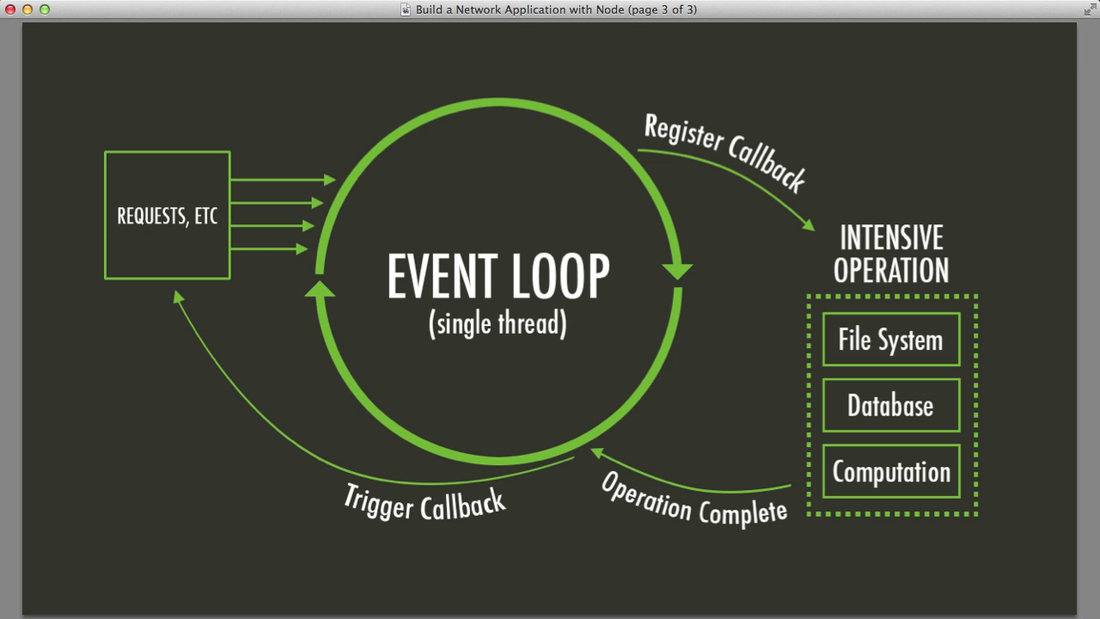

Non node JS Server Vs Node JS Server

http module

create http module program folder

node js provide pre-defined it url. This module help use to extract url details.

Node JS provided lot of pre-defined external web framework which help to do develop web application very easily.

Express JS : Express JS is a type of open source web application which help to create web application using node js program.

Express JS internally use http module to take the request from a client.

Express JS support all http protocol method like get, post, put and delete.

Express wrap http module.

Create the folder express module

npm install express locally

or

npm install express –g globally

package.json : This file contains all dependencies or modules configuration details.

npm init : which command is use to create the package.json file

we have to install express module

npm install express

npm install : it check in package.json file what are dependencies required to develop the application and those dependencies install locally.

npm uninstall modulename

npm uninstall mongodb

if method is get data send through url using query param concept using key=value pairs

url?key=value&key=value&key=value

if method is post data send through body part.

By default in Express data is not enable.

To enable this data we have to take the help to external module ie body-parser.

Express JS 3.x version we have to download body-parser module separately.

But from Express 4.x version onwards body-parser module part express JS.

In Express js we can take the help of use function.

To add other middleware modules.

Middleware means between client and server module

app.use(middlewaremodulename);

**Phase 3 :**

**Day 4**

20-02-2022

var num =[10,20,30,40];

var flag=0;

for(var i=0;i<num.length;i++) {

if(num[i]==100) {

flag++;

}

}

if(flag>0) {

console.log(“Present”);

}else {

Console.log(“not present”);

}

let result = num.find(obj=>obj==300);

if record present it will return that value else return undefined.

if(result!=undefined) {

consle.log(“Present”);

}else {

Console.log(“Not present”);

}

Express JS with HTML as a view.

View is a static we can’t do any dynamic task or we can’t use any variable value in html page which is part of node js application.

Express JS provide lot of pre-defined view-engine or express template. Which help to do dynamic task on view side.

Jade

Pug

Etc

Express js provided external module ie express-generator which help to create express js application with any of the view engine.

npm install express-generator –g

create separator folder as

express generator example

now to create the project we have to use the command as

express project-name

express project-name --view pug

express demo-app

cd demo-app

open the project in vs code

first run the command to install the external dependencies require to run the sample express project

npm install

to run the application run the command as

npm start

Create new folder

npm init

express demo-app

If we use any one of the express JS engine like Jade or pug or etc. We can do dynamic task on that engine.

The view engine tightly coupled with backend technologies like Express JS.

Req java request

Client HSBC XML/JSON SBI

Res Java Express JS

Js response

Express JS

Amazon

Payment Paytm Java

Google pay Asp.net

Net banking

Credit Python

Debit card Express JS

Web Service : Giving the service for web application when both application running using different technologies.

2 types of web service

1. SOAP base web service
2. RESTFull web service

SOAP : Simple Object Access Protocol.

Service consumer

Service Provider

Service Broker

WSDL file

UDDI Registry

SOAP Web service is base upon SOA (Service Oriented Architecture).

In SOAP web service we can consume and produce the data only in the form of XML (eXtensible Mark up language).

XML is very heavy.

RestFull Web service

Representational State Transfer

Using RestFull Web Service we can expose our resource as a web service in any format base upon client requirement.

Rest full web service can use only http or https protocol.

Restfull web service is just a style.

Restul web service is architecture style to expose our resources ie Express JS as we Web Service to consume and produce any format of data.

In Server side technologies like

Java Servlet or jsp or spring framework

Asp.net

Php

Express JS

Using this technologies we can receive the request from a client and response to client base upon the request.

ES6 object in JS

class Employee {

constructor(id,name,age) {

this.id=id;

this.name = name;

this.age = age;

}

}

let emp = new Employee(100,”Ravi”,21);

SOAP Web service

XML

<Employee>

<Id>100</Id>

<Name>Ravi</Name>

<Age>21</Age>

</Employee>

SOAP Request

SOPA Response

JSON : Java Script Object Notation

{“id”:100,”name”:”Ravi”,”age”:21}

Java

If we make Express JS application as a REST Full Web Service any other technologies can invoke or all our backend technologies.

View can be

Java

Asp.net

Php

Angular

React JS

Or other REST Client application

RestFull Web service using Express JS module

Using Express We will create REST API.

Those API is use to create, delete, update and retrieve resources.

Generally resources known as entity

Employee

Customer

Product

Order

Login

Etc

Create the folder

Express JS with REST API

Create the package.json file using npm init command

npm install express

REST API

Get method

1. Get the data in text format
2. Get the data in json format
3. Get employee resource in json format
4. Get all employee resources in json format.

Using get method passing the data to express js application

1. Query param
2. Passing single value : URL?key=value
3. Passing multiple value : URL?key=value&key=value

If view is normal html page internally they use query param concept.

1. Path param
2. Passing single value : URL/v1
3. Passing multiple value : URL/v1/v2

If view is normal html then we can use query param concept.

If view technologies is angular or react or command base rest client then you can use path param.

Post method : This method is use to create the resources

Store the information in file or database or array.

Patch method : This method is use to update existing resource partially.

Employee resource

We want to update age using id property

We want to update name using id property

Put method: Put method also update the existing resource.

Patch is use to update one more or more property but put method is use to update all property.

Delete method : This method is use to delete the resources.

We take the property value using path param.

**Phase 3 :**

**Day 5**

26-02-2022

Product Entity

Pid

PName

Price

Image

Create the Folder Express CRUD Operation

Backend : Express JS with REST API with FS module

Create the package.json file using npm init command

npm install express

then create product.json file

[]

Now create app.js file to do all express js operation.

npm install nodemon –g

nodemon is a external module if we run the express js application using nodemon module if we do any changes it automatically refresh the application.

Now onward rather than

node app.js

We have to use

nodemon app.js

Frontend : Angular

In Frontend folder create the angular project

ng new angular-product-app

ng new angular-product-app

routing : no

styling : css

Run these 3 command in angular project

create the component using command as

ng g c product

create the service using command as

ng g s product

create the model class using commands as

ng g class product

CORS : Cross Origin Resource Sharing :

Two domain going to communication each others.

Angular application running on port number 4200

Express JS running on port number 9090

Node Js provide external module ie cors enable to frontend technologies to access their resources.

In backend technologies install cors modules

npm install cors

add as a middleware